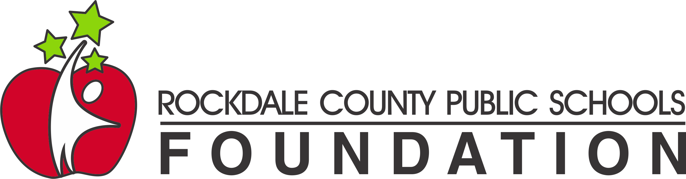

RCPS Foundation
2021-2022 Grant Application

DIRECTIONS
Please use this document to complete the Grant Application. Please place your responses under the appropriate question. This document should not exceed 4 pages. Margins should remain 1” with the font being Times New Roman or Calibri, 12pt.

PROJECT OVERVIEW
- Describe your project. (Max 300 words.)
- Why is this project needed? Include data that demonstrates and/or supports the need.
  - Is this a new project? YES NO (Circle one)
  - Is this an enhanced project? YES NO (Circle one)
PROJECT DETAILS
- How will student learning experiences be enhanced by this project?
- Describe how the project will be administered – what activities/materials/technology will be used to accomplish your project?
- Describe your targeted participants (# of students, grade level, subject area)
  - Does this project extend or complement other school curriculum activities? YES or NO (If yes, please explain.)
  - Can other teachers use this project? YES or NO
PROJECT EVALUATION
- How will you evaluate the success of your project?
- How will you share your success with other teachers/stakeholders?

BUDGET
- What are the costs associated with the project? Please be as specific as possible.
  - Materials and Supplies
  - Miscellaneous
  - Total

