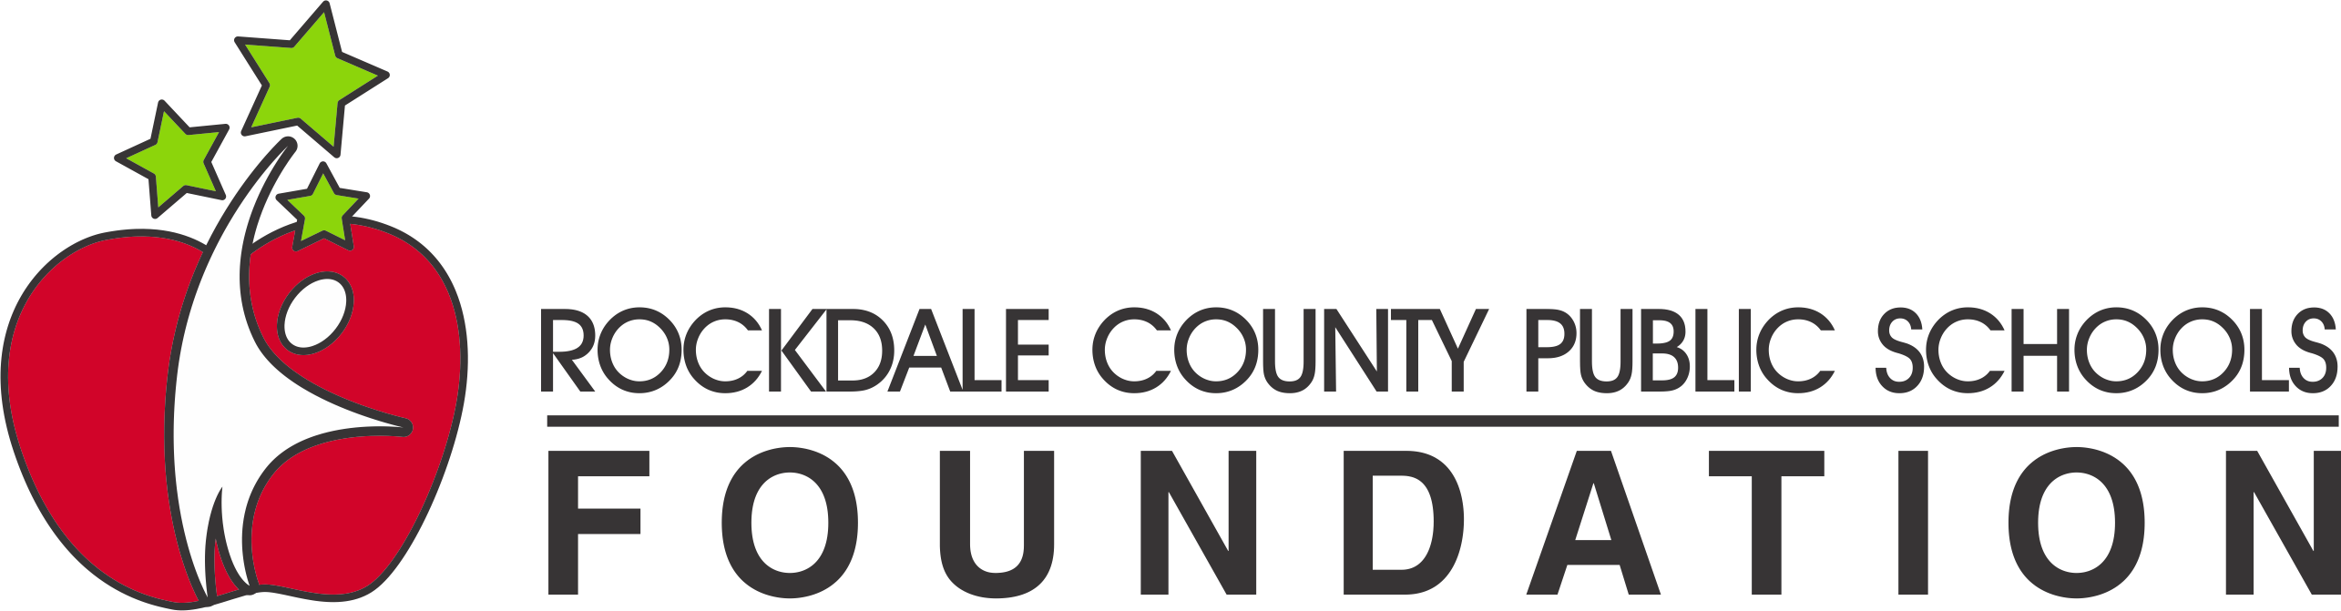

RCPS Foundation Grant Rubric

Grant Proposal #_______ Title of Project: ___________________________________________

New Project ____ Enhanced Project _____
3 – Strongly Agree | 2 – Agree | 1 – Disagree | 0 – Strongly Disagree/ Not Answered

# | Indicator | 3 | 2 | 1 | 0
1. | Application is complete with requested responses/information. If grant is not complete, it will not be sent to the judges for review.
2. | Project is innovative (Innovative = features new methods, new ideas, creative, advanced, original)
3. | Project fills a clearly defined need.
4. | Application clearly defines how this project will enhance students’ learning.
5. | Application clearly describes what students are expected to learn from this activity.
6. | Application clearly defines how the project will be administered.
7. | Project uses innovative practices to implement the project.
8. | Project extends or compliments other school curriculum activities.
9. | Clearly describes who will be involved/impacted by the project.
10. | Application clearly describes how the project will be evaluated.
11. | Application clearly describes how the results will be shared with others.
12. | Project can be replicated by other teachers.
13. | Application provides a detailed budget.
14. | Requested budget amount calculations are accurate and within the grant guidelines.
15. | Budget contains reasonable items that will facilitate the objectives of the project.
16. | All items included in the budget are explained/referenced in the grant proposal.
Overall/General Impressions
17. | This project is relevant to the current needs of students.
18. | If implemented as stated, this project will meet its objectives.
Total of Each Column
Total points (Maximum points = 51)
3.8.2021

